Day 22 Revisit

* Pub/Sub Model – Publish & Subscribe
* Producer/Consumer Pattern
* Producer produce data
* Consumer consumes data
* Writer & Reader [Write & Read Operation]
* Kafka – Open Source, distributed Event Streaming platform.
* Kafka Installation.
* Event Streaming VS Message Queue (Kafka vs RabbitMQ)
* Started Zookeeper (Monitoring Data & Process) server & Kafka Server.
* Created event with Kafka Producer.
* Consumed it with kafka Consumer.
* File Handling with Kafka connect tool.
* Streams handling with Kafka.
* Kafka with SpringBoot and demo.
* Kafka – Digital version of human body nervous system.
* Installed Docker Desktop by enabling Hyper-V, WSL2

Day 23 Agenda

* Docker
* Introduction to Docker
* Docker Architecture
* The Docker Hub
* Docker Installation
* Creating Our First Image
* Working with Multiple Images
* Containers
* Packaging A Customized Container
* Running Container Commands with Docker
* Exposing Our Container with Port Redirects
* Exercise: Exercise: Installation and Image Setup
* Exercise: Exercise: Creating Images from Containers
* Exercise: Exercise: Exposing Container Ports to the Host
* Docker Hub, Docker Compose

Docker - <https://www.docker.com/>

Docker is one of the DevOps Tool.

DevOps = Development + Operations

Docker is a containerization Tool,

Images & Containers

Virtual Machine – A Machine in Cloud/OS installed in the current OS.

IaaS or PaaS – Virtual Machine.

IaaS – Infrastructure as a Service

PaaS – Platform as a Service

SaaS – Software as a Service

Dual Booting/ Multi Partition.

Virtualization Tools – It helps in Installing another OS inside the current OS.

Actually installed one is called as Host – Virtual one is called as guest/client/node.

Docker Client [ CLI Client/GUI Client (Docker Desktop)]

Docker CLI client. [Normal Command prompt having the power to execute docker commands]

1. Docker Client
2. Docker HOST (Server/Engine) [Docker Deamon, Images, Containers]
3. Docker Hub/Registry (hub.docker.com) [Cloud Image Storage Service]

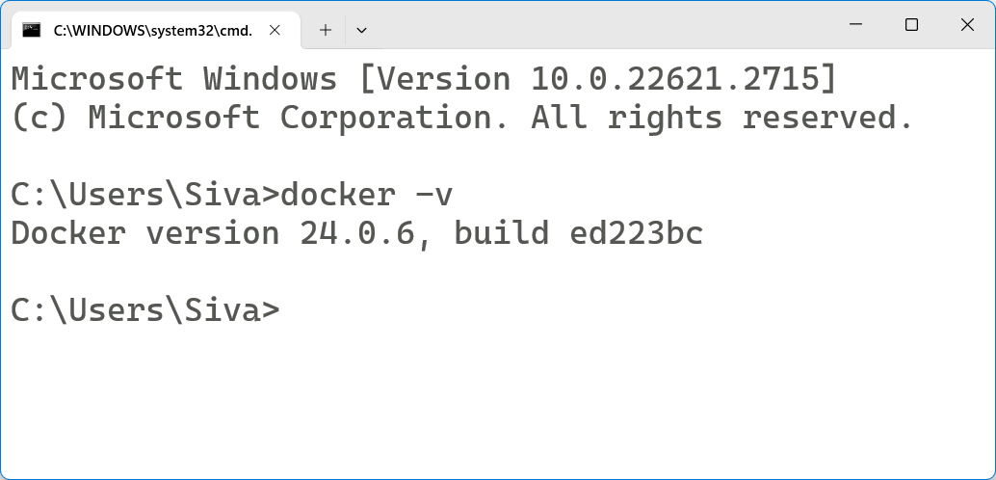

Docker Desktop (GUI Client)

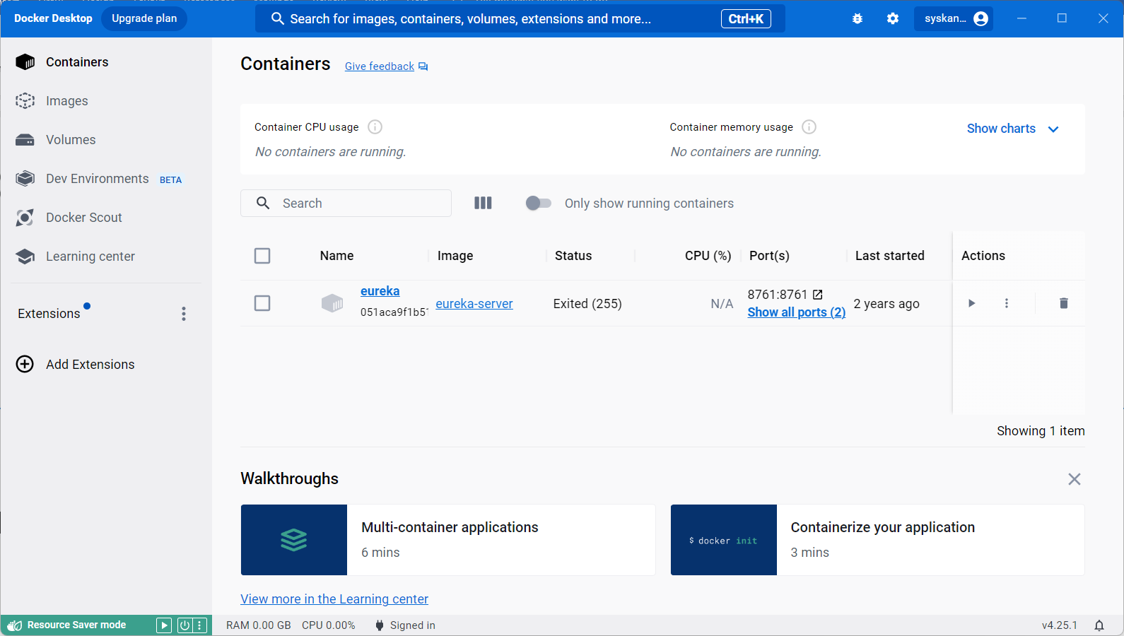

Images VS Containers

Images – Is a single file which contains everything to run the code (Class)

Container – Is a running version of images. (Object)

<https://geekflare.com/docker-architecture/>